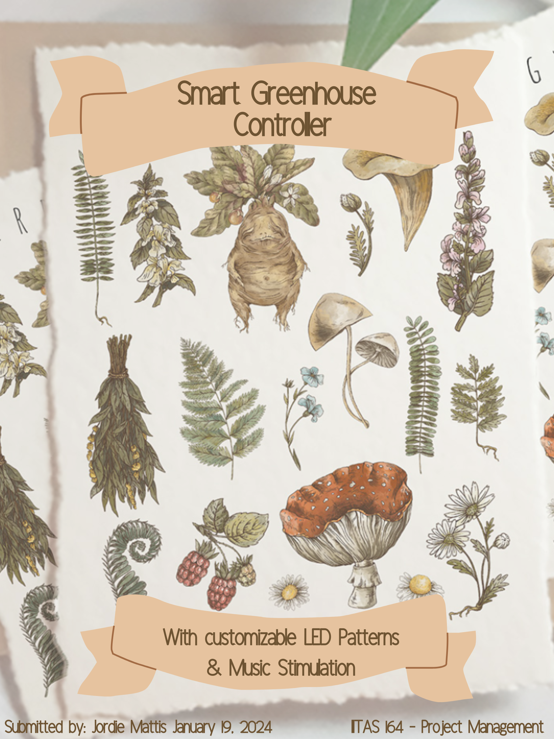



Contents
Project Topic 3
Needs Analysis 3
Technology Background and Resources 3
Stakeholders 4
Key Tasks and Milestones 4
Division of Labour/Resources 5
Potential Limitations and Risks 5
Requirements for a Successful Solution/Product 6
References and Resource Links 7

Project Topic
Eco-Friendly Smart Greenhouse Controller:
For this project we would be utilizing a Raspberry Pi, which would monitor and control environmental factors such as temperature, humidity, watering and light in a small greenhouse with multiple plants.
Unlike most greenhouse controllers this project uniquely integrates plant stimulation via music and programmable LED light patterns.

Needs Analysis
Existing smart greenhouse solutions are often expensive and lack special features. This project addresses these gaps by providing a cost-effective and customizable system. As well as the addition of music and light stimulation for plant growth, which sets it apart from typical DIY projects and commercially available products.
Musical stimulation of plants is based on the idea that sound waves, particularly from music, may positively affect plant growth and health. Studies suggest that the vibrations produced by music can stimulate plant physiological processes, potentially influencing their growth and development.
Programmable LED light patterns refer to the ability to control and customize the behavior of LED lights, particularly in terms of their timing, intensity, color spectrum, and sequence. This functionality helps plant growth stimulation.

Technology Background and Resources
Required components include:
- Raspberry Pi 3 Model B+ (approx. $70-$100): Central controller.
- Environmental Sensors ($30-$50): To monitor temperature, humidity, and light.
- Relay Module ($5-$10): For device control.
- LED Grow Lights ($20-$50): For light control and stimulation.
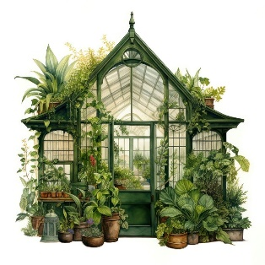
- Speakers ($10-$30): For music stimulation.
- Water Pump & Filtration System ($30-$60): For purifying water and watering plants.
- Miscellaneous ($20-$30): Wires, breadboard, seeds etc.
- Ideal for a team of 3.
Total estimated cost: approx. $185-$330.

Stakeholders
Sponsor: Educational institution or research body with a primary interest is in the educational and research outcomes of our project. Seeking to use this project as a case study, for advancing sustainable practices, or for enhancing the institution's reputation in technological and environmental innovation. Potential interest in promoting STEM education through practical projects like this.
Clients: Eco-conscious gardeners, small-scale greenhouse operators looking for cost-effective, efficient, and sustainable solutions to enhance plant growth and greenhouse management. The added features like sound and light stimulation for plant growth would be particularly appealing to this group for customizability to their specific needs.
Users: Students, hobbyists, and educators in sustainability and agriculture interested in understanding and utilizing our technology for learning, teaching, or hobbyist activities.

Key Tasks and Milestones
Project Timeline Breakdown
Initial Planning and Design (1 week):
- Finalizing project scope and objectives.
Procurement of Components (1-2 weeks):
- Ordering and acquiring all necessary components like Raspberry Pi, sensors, relay modules, LED lights, speakers, and water system parts.
- This phase can run concurrently with other tasks.
Basic Setup and Programming (2 weeks):
- Setting up the Raspberry Pi.
- Basic programming for sensor reading and control functions.

Environmental Control System Development (2 weeks):
- Integrating temperature, humidity, and light sensors.
- Developing control logic for environmental regulation.
Water System Integration (1 weeks):
- Setting up the water pump and irrigation system.
- Integrating it with the Raspberry Pi for automated watering.
Sound and Light Stimulation System Implementation (2 weeks):
- Installing and programming LED grow lights and speakers.
- Testing different light and sound patterns for plant stimulation.
Testing and Calibration (2 weeks):
- Thorough testing of all systems.
- Calibration of sensors and fine-tuning the control systems.
Final Assembly and Deployment (1 week):
- Making any final adjustments based on testing.
- Assembling all components in the greenhouse.
- Final deployment and operational testing.
Total Estimated Duration: 10-12 weeks

Division of Labour/Resources
Member 1: Hardware assembly, focusing on sensor and water system integration.
Member 2: Software development, including programming for environmental control and watering.
Member 3: Implementing and testing the light and music stimulation system, along with final aesthetic design.

Potential Limitations and Risks
Component Sourcing: Difficulty in acquiring specific sensors or water system parts.
Budget Overrun: Maintaining quality while adhering to budget constraints.

Plant Type Limitations: The greenhouse controller will be designed to manage a range of environmental factors like temperature, humidity, and light; however, different plants have varied requirements. There is a risk that the system might not be optimally configured for all types of plants, which could limit its effectiveness or appeal to users with diverse planting interests.

Requirements for a Successful Solution/Product
Accurate Environmental Control: Reliable monitoring and adjustment of greenhouse conditions.
Effective Plant Stimulation: Demonstrable benefits from the music and light stimulation on plant growth.
Durability and Reliability: Ensuring system operates efficiently over time.





References and Resource Links
Raspberry Pi and Sensor Setup: https://www.raspberrypi.com/documentation/
https://www.instructables.com/Raspberry-Pi-Controlled-Irrigation-System/
https://www.raspberry-pi-geek.com/Archive/2014/07/Building-a-Raspberry-Pi-greenhouse
Plant Growth and Light Patterns:
https://ledgardener.com/
https://www.ledyilighting.com/led-grow-light-guide/
Musical Effects on Plant Growth:
https://www.independent.co.uk/arts-entertainment/music/news/plants-music-study-growth-b2269710.html https://www.smilinggardener.com/plants/music-and-plants/
https://www.earth.com/news/plants-that-listen-to-music-grow-faster-and-healthier/
Tutorials for building a Greenhouse Controller: https://www.youtube.com/results?search_query=raspberry+pi+greenhouse+controller
Parts Cost Estimates:
www.amazon.ca
www.google.com

